Sam Tenney

Section 2

Homework 10

1. Microwave Popcorn
2. Response variable: percentage of popped kernels for each bag.
3. Whole-plot factor: Popcorn Brand (Expensive, Generic)

Experimental unit for the whole-plot factor: Individual box of six microwavable bags of popcorn

1. Split-plot factor: Temperature (Frig, Room)

Experimental unit for the split-plot factor: Individual bag from box of microwavable popcorn

1. Box is nested within Brand since one box cannot be both expensive and generic, but there are boxes for both expensive and generic brands of popcorn.
2. Bag is nested within Box because you will always have a unique bag number with each box, but across boxes you could, for example, have the first bag from multiple boxes. The same bag can’t come from multiple boxes.
3. Temperature is crossed with Brand because both temperatures (Frig, Room) occur across both Brands (Expensive, Generic).
4. We are using an SP[1;1] model with yijk = µ + αi + βj(i) + γk + δik + ɛ­ijk where yijk is the percentage of popped kernals from Popcorn Brand level i (Expensive, Generic) with Box j (nested in i) and temperature (Frig, Room) level k, µ is the grand mean of all the kernals popped, αi is the treatment effect for the ith Brand level, βj(i) is the block effect for the jth Box (nested in i), The variable γk is the treatment effect for the k­th Temperature level, δik is the interaction effect for the ith Brand level and the kth Temperature level, and ɛ­ijk is the error for the ith Brand level on Bag j (nested in i) and the kth Temperature level.

In this model, i = 1, 2 indexes levels of the Brand (Expensive, Generic), j = 1, …, n indexes Bags nested in the ith level of Brand, k = 1, … , K indexes levels of the Temperature (Frig, Room).

1. H­­NullBrand: α1 = α2 = 0

HAltBrand: At least one αi ≠ 0

1. H­­NullTemperature: γ1 = γ2 = 0

HAltTemperature: At least one γk ≠ 0

1. H­­NullBrandxTemperature: δ11 = δ12 = … = δik = 0

HAltBrandxTemperature: At least one δik ≠ 0

1. # Read in the data  
   popcorn <- read.table(text = "Brand,Temp,Box,Bag,% Popped  
   Expensive,Room,1,1,84  
   Expensive,Frig,1,2,76  
   Expensive,Room,2,3,86  
   Expensive,Frig,2,4,86  
   Expensive,Room,3,5,91  
   Expensive,Frig,3,6,84  
   Generic,Room,4,7,74  
   Generic,Frig,4,8,87  
   Generic,Room,5,9,84  
   Generic,Frig,5,10,83  
   Generic,Room,6,11,83  
   Generic,Frig,6,12,90", header = TRUE, sep = ",")

# Look at the data  
str(popcorn)

## 'data.frame': 12 obs. of 5 variables:  
## $ Brand : Factor w/ 2 levels "Expensive","Generic": 1 1 1 1 1 1 2 2 2 2 ...  
## $ Temp : Factor w/ 2 levels "Frig","Room": 2 1 2 1 2 1 2 1 2 1 ...  
## $ Box : int 1 1 2 2 3 3 4 4 5 5 ...  
## $ Bag : int 1 2 3 4 5 6 7 8 9 10 ...  
## $ X..Popped: int 84 76 86 86 91 84 74 87 84 83 ...



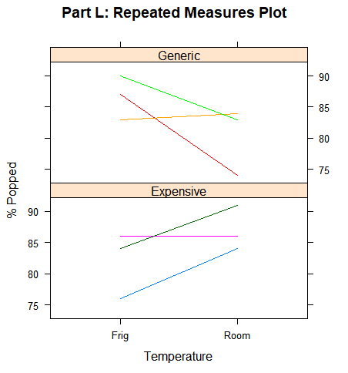

|  |  |  |  |  |  |
| --- | --- | --- | --- | --- | --- |
| ANOVA Table | | | | | |
| Error: Box | | | | | |
| Source | Df | Sum Sq | Mean Sq | F value | P value |
| Brand | 1 | 9.26 | 9.26 | -- | -- |
| Error: Within |  |  |  |  |  |
| Source | Df | Sum Sq | Mean Sq | F value | P value |
| Brand | 1 | 84.87 | 84.87 | 7.80 | 0.03 |
| Temp | 1 | 1.33 | 1.33 | 0.12 | 0.74 |
| Brand:Temp | 1 | 96.33 | 96.33 | 8.85 | 0.02 |
| Residuals | 7 | 76.21 | 10.89 | -- | -- |

1. We reject H­­NullBrand because the p-value for the Brand main effect is small (0.03). The brand of popcorn is statistically significant when describing the percentage of kernels that popped. We fail to reject H­­NullTemperature because the p-value for the Temperature main effect is very large (0.74). We reject H­­NullBrandxTemperature because the p-value for the interaction effect is very small (0.02). The difference in the interaction effects is statistically significant.

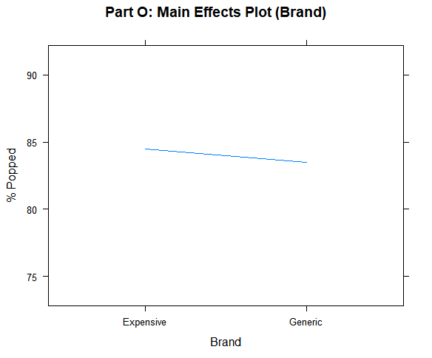

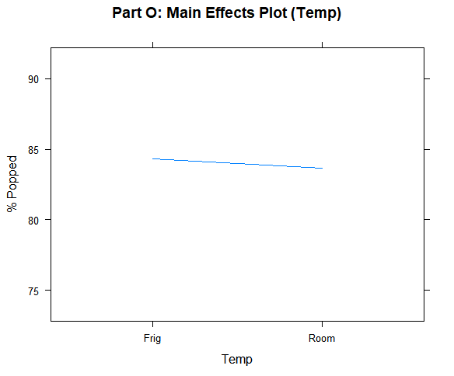

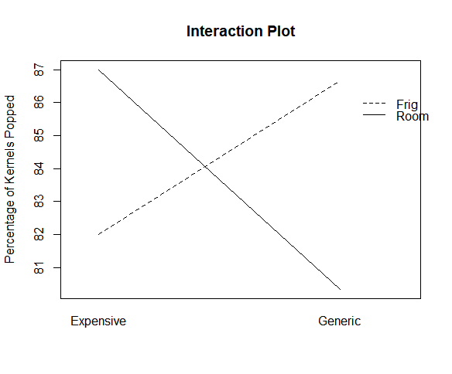There seems to be an interaction between Brand and Temperature. The main effect plots don’t show much of a difference between each Brand and each Temperature. The Expensive-Room Temperature popcorn seemed to have the highest percentage of kernels popped with Refrigerated-Generic popcorn close behind.

1. # Calculate grand mean, mean for each Brand, and the Brand effects  
   mean(popcorn$X..Popped)

## [1] 84

brandMean <- aggregate(X..Popped~Brand, data=popcorn, FUN=mean)  
brandMean

## Brand X..Popped  
## 1 Expensive 84.5  
## 2 Generic 83.5

The Brand effect for expensive is 0.5 (84.5 – 84), while the Brand effect for the generic popcorn is -0.5 (83.5 – 84). You can see that the expensive brand is slightly above 84 on the “Part O: Main Effects Plot (Brand)” plot in part o, while the generic brand is slightly below 84.

1. Temperature

# Calculate the grand mean, the mean for each Temperature, and the Temperature effects  
mean(popcorn$X..Popped)

## [1] 84

tempMean <- aggregate(X..Popped~Temp, data=popcorn, FUN=mean)  
tempMean

## Temp X..Popped  
## 1 Frig 84.33333  
## 2 Room 83.66667

The Temperature effect for the Refrigerator temperature popcorn is 0.33 (84.33 – 84). The Temperature effect for the room temperature popcorn is -0.33 (83.67 – 84). You can see that the Refrigerator temperature is slightly above 84 on the “Part O: Main Effects Plot (Temp)” plot in part o, while the Room temperature is slightly lower.

1. Interaction

# Calculate the grand mean, the mean for each Brand x Temperature, and the interaction effects  
mean(popcorn$X..Popped)

## [1] 84

brandTempMean <- aggregate(X..Popped~Brand+Temp, data=popcorn, FUN=mean)  
brandTempMean

## Brand Temp X..Popped  
## 1 Expensive Frig 82.00000  
## 2 Generic Frig 86.66667  
## 3 Expensive Room 87.00000  
## 4 Generic Room 80.33333

The interaction effect for Expensive-Frig is 82 – 84 – 0.5 – 0.33 = -2.83

The interaction effect for Generic-Frig is 86.67 – 84 – (-0.5) – 0.33 = 2.84

The interaction effect for Expensive-Room is 87 – 84 – 0.5 – (-0.33) = 2.83

The interaction effect for Generic-Room is 80.33 – 84 – (-0.5) – (-0.33) = -2.84

The interaction can be seen on the Interaction Plot in part o. For example, the two positive interactions are Generic-Frig and Expensive-Room. On the interaction plot, both of those points are above the grand mean of 84.